Hi Jia,

Based on our discussions in class a while ago, Chung-Ying and I are visualizing open spaces in public schools in Manhattan. We are trying to create a stacked bar graph of each school showing its relationship of their outdoor spaces to their indoor spaces and you also suggested that we should look into outdoor spaces sqft/ student which is interesting. We are struggling to sort the data as each school has an independent entry for indoor and outdoor spaces, and if a school has multiple indoor or outdoor spaces, they will have more entries. Like in the example below, PS 20 has 4 different spaces, 3 indoors and 1 outdoor, and they all have their own entry. Our goal is to consolidate all the entries of each school into one entry to determine their indoor/outdoor relationship.

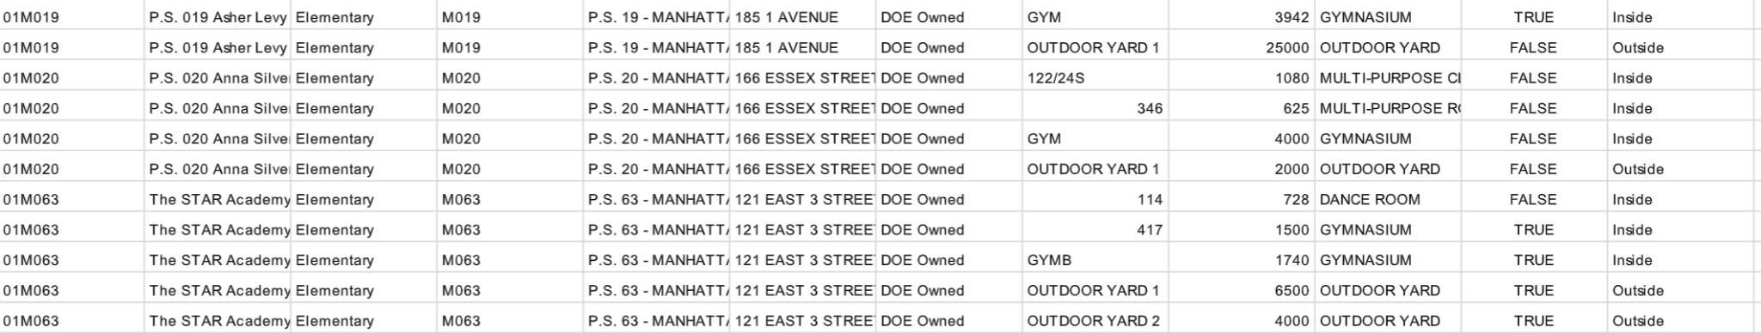

Below is what we were able to come up with for our bar chart. We hope this is enough information for you to help us solve our problem. Our goal is for the graph to look something similar to the second image. We would like to create a stacked bar chart that segregates the indoor and outdoor spaces of each school where indoor spaces and outdoor spaces are always grouped together and indoor spaces are always on top of the outdoor spaces. Please let us know if you have more questions. I have also attached our code and the data that we used for the visualization.

**(below: what we have now…)**

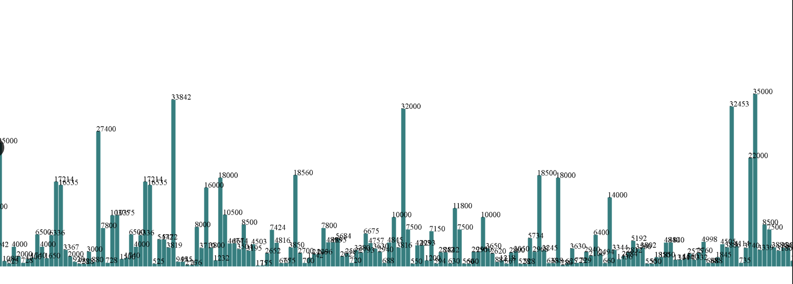

**(below: what we wanna make…)**

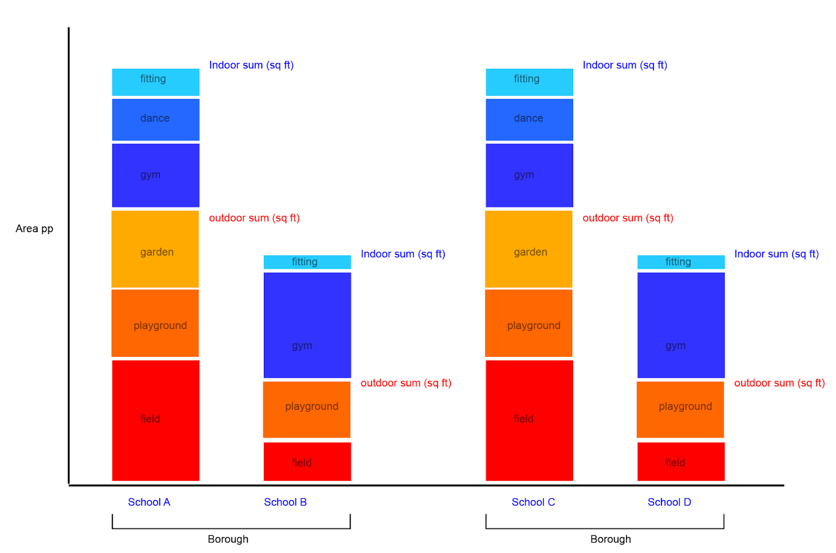

I'm also starting this google doc to compile all our questions and email exchanges so we can come back to it in the future. If you want you can give us feedback here!

<https://docs.google.com/document/d/14-rIDlArnYhgRWB-7Ys91fu4_wputxmXGiysdoJku1Q/edit?usp=sharing>

In summary,

**1. How do we consolidate and sort multiple entries of data into 1 (combining data of the same school) and bring together multiple csv files.**

**2. How do we create a stacked bar chart**

**3. How do we segregate the stacked barchart where indoor or outdoor spaces are always grouped together, and in each group, listed in a certain order that is defined by room functions (which varies from school to school)**

**4. How do we segregate the indoor and outdoor space in such a way that indoor is always on top and outdoor is always under**

**5. Do you recommend any website where we can find simple examples that write code in a similar manner as yours and the tutorial? (cuz sometimes we find examples but cannot fully understand them.)**

Best,

Paul and Chung-Ying